Techniques and tools

Frontend Framework :

1.React JS:
React.js was selected as the core framework for developing the frontend of the apartment rental platform due to its modular and dynamic nature. Key features used include:

Component-Based Architecture:
Built reusable components such as property cards, search bars, filters, and user authentication modals.
Ensured consistency and reduced redundancy by organizing components logically within feature-based folders.

React Hooks:
Used useState to manage states like filter selections, form inputs, and user authentication.
Implemented useEffect for handling side effects, such as fetching property data from Firebase in real-time and monitoring changes.

React Router:
Integrated React Router to enable navigation across pages (e.g., Home, Apartment Listings, User Profile, and About Us) without full page reloads, creating a seamless user experience


2. Styling Framework:
Tailwind CSS
Tailwind CSS was used for its efficiency in designing modern, responsive, and visually appealing interfaces tailored for real estate listings.

Custom Themes:
Configured Tailwind’s theme in tailwind.config.js to reflect a professional color palette, such as warm neutrals and blues, representing trust and reliability in real estate.
Responsive Design:
Ensured the website was mobile-friendly by designing layouts with responsive utility classes to accommodate all screen sizes, from smartphones to large monitors.


3. State Management

To manage data flow and application state:

React Context API:
Used for sharing global states like active filters (e.g., price range, location, and amenities) and user login status across the application without prop drilling.
Local State Management: Managed component-specific states for dynamic features like search queries and form validations.

Redux
Redux was used to handle the global state of the apartment rental platform efficiently. Key features include:

Centralized State: Managed filters, apartment listings, user authentication, and reviews in a single global store.
Actions and Reducers: Defined reusable actions (e.g., FILTER_APARTMENTS, ADD_REVIEW) and reducers to update the state predictably.
Middleware: Used redux-thunk for asynchronous tasks like fetching apartment data and submitting reviews.
React Integration: Connected Redux to React using react-redux, utilizing useSelector for accessing state and useDispatch for dispatching actions.
Improved Performance: Cached data like apartment listings to minimize API calls and enhance responsiveness.


- Build Tools: Vite and npm

Vite: Used for fast development with Hot Module Replacement (HMR) and optimized production builds. Custom configurations in vite.config.js supported Tailwind CSS and Firebase integration.

npm: Managed dependencies (e.g., React, Redux, Firebase) and provided scripts for development (npm run dev), production build (npm run build), and preview (npm run preview).

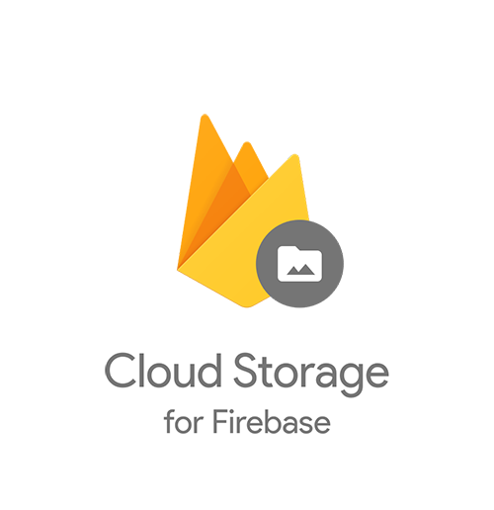
- Third-Party Service: Firebase Storage

Firebase Storage was utilized for storing and managing user-uploaded images, such as apartment photos. Its integration simplified handling large files and ensured reliable, scalable storage. Key features include:

Seamless Integration:
Integrated with the Firebase SDK to easily upload, retrieve, and manage image files directly from the application.

Scalability:
Supported storing high-resolution images without impacting app performance, ensuring the platform can handle increasing user activity.

Security Rules:
Configured Firebase security rules to control access, ensuring only authenticated users can upload images and restricting downloads as per user roles.

Real-Time URL Generation:
Generated secure download URLs after each upload, which were stored in the database and used to display images on the platform.

Cost-Effectiveness:
Benefited from Firebase's pay-as-you-go pricing, making it a cost-efficient choice for storage needs.

- Version Control: Git and GitHub

Git: Used locally for tracking code changes, managing feature branches, and enabling easy rollbacks.

GitHub: Hosted the repository for collaboration, pull requests, and code reviews, while serving as a secur e backup.


- Analytics and Monitoring :

Google Analytics
Google Analytics was integrated into the project to track and analyze user interactions, providing valuable insights for improving the platform.

Key Features:
Real-Time Monitoring: Tracked active users, pages visited, and interactions as they occurred.
User Behavior Analysis: Collected data on how users navigated the site, including frequently visited pages, filters used, and time spent on listings.
Traffic Sources: Identified where users originated from (e.g., search engines, social media, or referrals), helping optimize marketing strategies.
Event Tracking: Monitored specific actions, such as apartment searches, clicks on "Contact Owner," and image uploads.

Helped understand user preferences and behavior, enabling data-driven improvements to the platform.
Monitored conversion rates, such as users signing up or submitting apartment reviews.

- Backend Development

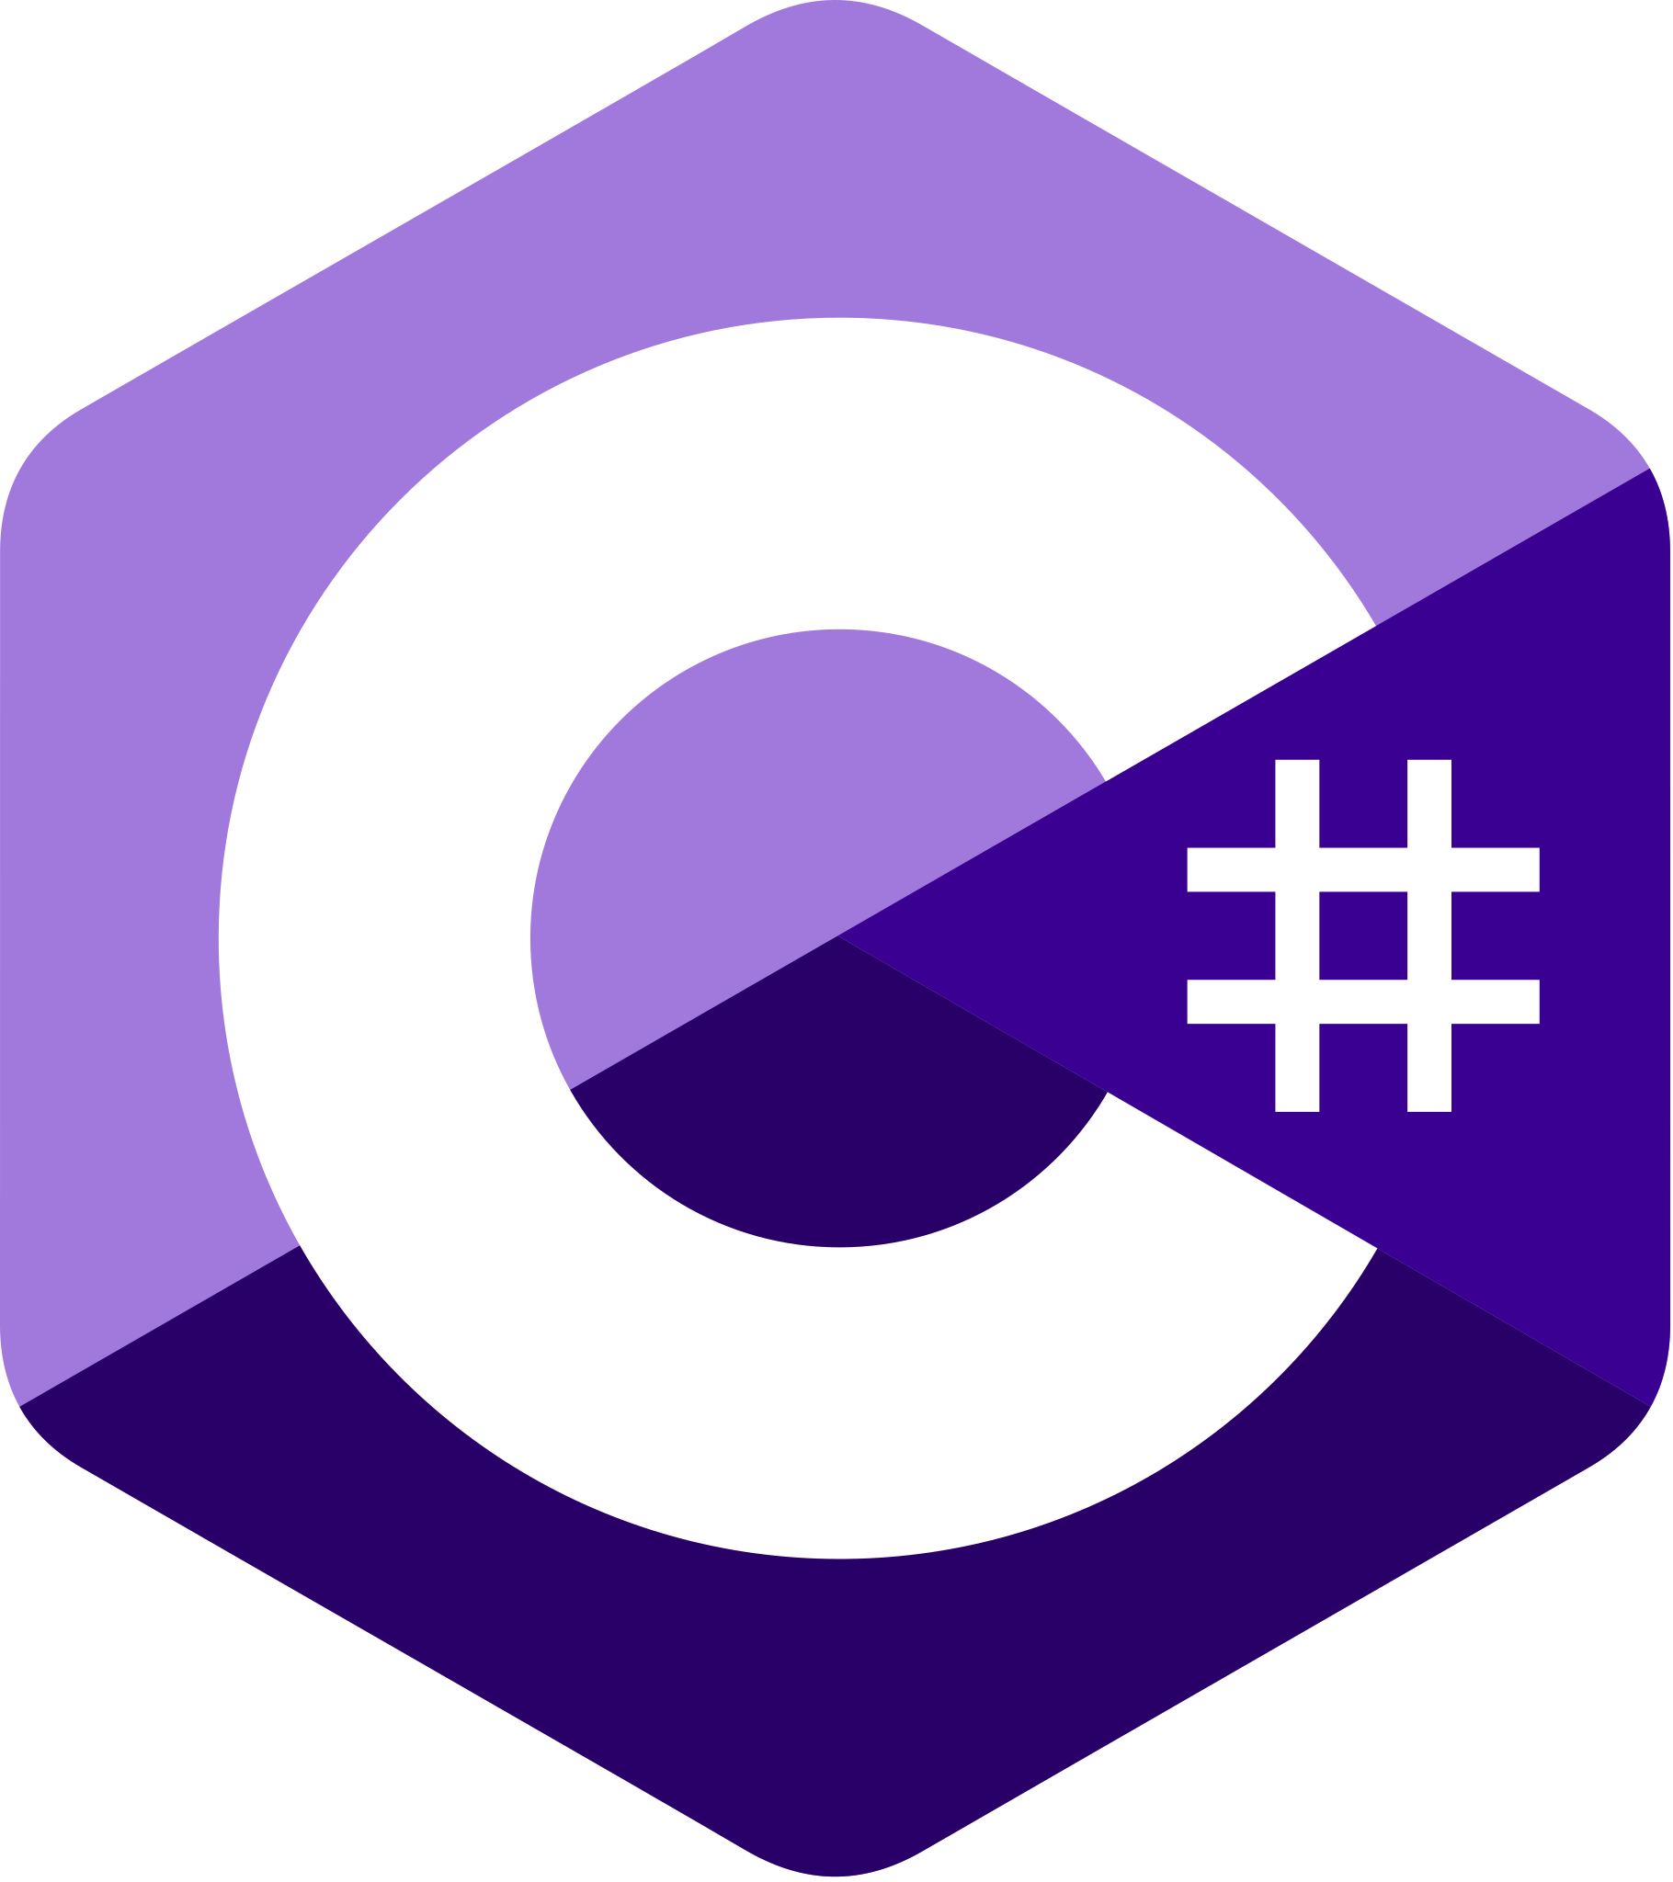
1.C#
C# was chosen as the programming language for backend development due to its versatility and strong integration with .NET. Key features include:

Object-Oriented Programming: Enabled modular, reusable, and maintainable code, essential for implementing business logic for user management, apartment listings, and reviews.
Asynchronous Programming: Used async/await for handling asynchronous tasks like database queries and API calls, improving server responsiveness.
Robust Error Handling: Implemented try-catch blocks and custom exception handling to ensure stability and provide detailed error messages for debugging.
Integration Support: C#’s rich library ecosystem facilitated seamless integration with Firebase for image storage and third-party tools like Google Analytics.


2.NET Framework
ASP.NET Core, a modern and high-performance web framework, powered the backend with the following features:

RESTful API Development:Designed endpoints for CRUD operations on apartments, user accounts, and reviews. Supported HTTP methods like GET (retrieve apartments), POST (add reviews), PUT (update user info), and DELETE (remove listings).
Middleware:Used custom middleware for logging, error handling, and request validation.
Implemented authentication middleware to validate tokens and secure API access.
Dependency Injection:
Integrated DI to manage services like database contexts and external API clients, enhancing code modularity and testability.

Authentication and Authorization:
Implemented JWT (JSON Web Token) for user authentication and role-based authorization to differentiate access for normal users, premium users, and admins.

- SQL Server

SQL Server served as the relational database for managing structured data in the application. Key aspects include:

Database Design:
Tables were designed with proper normalization to reduce redundancy and improve data integrity.
Users: Stored user details, authentication information, and roles.
Apartments: Included details like location, price, amenities, and image URLs.
Reviews: Managed user feedback with fields for ratings, comments, and timestamps.

Stored Procedures:
Created stored procedures for complex queries like fetching apartments with filters applied and calculating average ratings.
Improved performance by reducing the load on the application layer and optimizing query execution.

Indexes:
Added indexes on frequently queried fields (e.g., apartment location, price) to speed up search operations.

Transactions:
Used transactions to ensure consistency during critical operations, such as booking apartments or submitting reviews, to prevent partial updates.

- Third Party Services


SendGrid:Email Delivery Service
SendGrid is a cloud-based email delivery platform that provides businesses with the tools to send transactional and marketing emails at scale. It offers a range of APIs and SMTP services for email delivery, along with analytics to track email performance, ensuring high deliverability rates and reliable service. SendGrid is popular among developers for its ease of integration with both small applications and large-scale enterprise systems.
Email API: Allows developers to send email messages from their applications, with options for both transactional and marketing emails.
SMTP Relay: Provides a reliable service for sending emails using the SMTP protocol, making it easy to integrate into existing systems.
Deliverability Tools: Includes tools to track email delivery, open rates, click rates, and more, to optimize performance.
Templates and Personalization: Users can create and send customized email templates for better engagement with recipients.
Scalability: Supports both small and large-scale email sending needs, suitable for businesses of any size.
Security: Offers features like email authentication and encryption to protect against phishing and unauthorized access.
Use Cases:
Sending transactional emails (e.g., order confirmations, password resets).
Running marketing campaigns with advanced email personalization.
Integrating email services with web applications via API.


PayMob:Payment Gateway
PayMob is a leading payment gateway in Egypt, designed to facilitate secure online transactions for businesses and consumers. It provides an API for processing payments, enabling businesses to accept payments via credit/debit cards, mobile wallets, and other local payment methods. PayMob is widely used by e-commerce businesses, subscription services, and retail merchants to offer a seamless and secure payment experience.

Key Features:
Payment Gateway API: Allows businesses to process payments from customers via a wide range of local and international payment methods.
Mobile Wallet Integration: Supports popular mobile wallets, including Fawry, Vodafone Cash, and others for easy mobile-based payments.
Recurring Payments: Enables subscription-based services to collect payments on a regular basis.
Fraud Detection: Provides advanced security features, including fraud prevention tools, to protect businesses from fraudulent transactions.
Invoicing: Facilitates generating and managing invoices directly from the PayMob platform.
Local Integration: Tailored specifically for the Egyptian market, with support for local banks and payment methods.
Use Cases:
Enabling e-commerce sites to accept payments securely.
Providing subscription-based businesses with recurring billing solutions.
Integrating mobile wallet payments for greater convenience.

Twilio:SMS Messaging API

Overview:
Twilio provides a powerful SMS API for businesses to send and receive text messages globally. It allows seamless integration of SMS capabilities into web and mobile applications, enabling businesses to automate notifications, alerts, reminders, and two-way messaging. With robust scalability and reliable delivery, Twilio ensures effective communication for organizations of all sizes.

Key Features:
Send SMS: Quickly send text messages to customers worldwide through a simple API.
Receive SMS: Enable two-way communication by receiving replies directly in your application.
Phone Number Management: Purchase, configure, and manage virtual phone numbers to customize messaging.
Global Reach: Deliver SMS to over 180 countries with high reliability and fast delivery rates.
Programmable Messaging: Personalize messages with templates and variables for tailored communication.
Delivery Status Tracking: Monitor the status of sent messages with detailed delivery reports.
Scalability: Supports large-scale messaging for campaigns, promotions, or transactional alerts.
Use Cases:
Sending transactional messages like OTPs, confirmations, and alerts.
Running SMS-based marketing campaigns.
Automating customer notifications, reminders, and updates.
3.Machine Learning Model

1. Python
Python served as the primary programming language for implementing the recommendation system due to its:

Rich Ecosystem: Extensive libraries and tools for data manipulation, visualization, and machine learning.
Ease of Use: Simple syntax that accelerates development and experimentation.
Community Support: Access to a vast range of resources, tutorials, and pre-built models.

2. TensorFlow
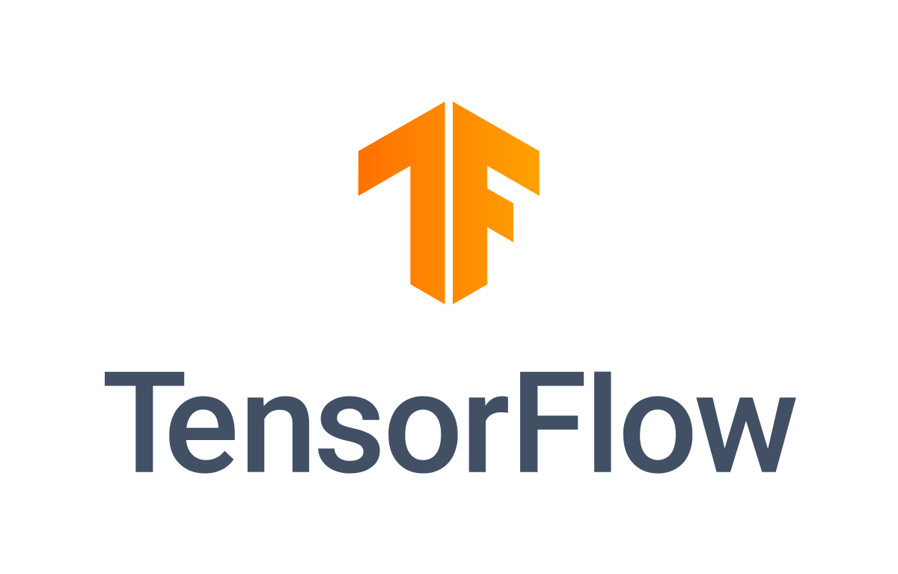
TensorFlow, an open-source machine learning framework, was used for building and training the recommendation model.

Key Features Utilized:

Deep Learning Support:
Designed a neural network architecture optimized for collaborative filtering or content-based recommendations.
Ease of Deployment:
TensorFlow's model export capabilities allowed easy integration of the trained model with the backend.
TensorFlow Recommenders (TFRS):
A specialized library within TensorFlow, TFRS provided prebuilt tools for creating recommendation systems, reducing development time.

Advantages:
Scalability: Handled large datasets of user reviews, apartment details, and preferences efficiently.
Performance: TensorFlow’s GPU support accelerated training times for large-scale models.
Customizability: Allowed fine-tuning of the model to cater to unique aspects of the rental platform, such as prioritizing recent reviews or higher-rated apartments.

